|  |
| --- |
| HDSSD |
| Requirements Specification (RS) |
| Contractor Contactor |

|  |
| --- |
| Ronan Behan x19141815  2/22/2021 |

Requirements Specification (RS)

Document Control

Revision History

|  |  |  |  |  |  |
| --- | --- | --- | --- | --- | --- |
| **Date** | **Version** | **Scope of Activity** | **Prepared** | **Reviewed** | **Approved** |
| 21/2/21 | 1 | Create | Yes |  |  |
|  |  |  |  |  |  |

Distribution List

|  |  |  |
| --- | --- | --- |
| **Name** | **Title** | **Version** |
| Hamilton Niculescu | Lecturer |  |
|  |  |  |
|  |  |  |
|  |  |  |
|  |  |  |

Related Documents

|  |  |
| --- | --- |
| **Title** | **Comments** |
|  |  |
|  |  |

**Table of Contents**

1 Introduction 4

1.1 Purpose 4

1.2 Project Scope 4

1.3 Definitions, Acronyms, and Abbreviations 6

2 User Requirements Definition 6

3 Requirements Specification 7

3.1 Functional requirements 7

3.1.1 Use Case Diagram 9

3.1.2 Requirement 1 <Log In> 10

3.1.3 Requirement 2 < Enter Profile > 11

3.1.4 Requirement 3 < Enter Notice Board > 13

3.1.5 Requirement 4 < View Contractor Profile > 15

3.1.6 Requirement 5 < Administrator Help > 16

3.2 Non-Functional Requirements 18

3.2.1 Performance/Response time requirement 18

3.2.2 Availability requirement 18

3.2.3 Recover requirement 18

3.2.4 Robustness requirement 18

3.2.5 Security requirement 18

3.2.6 Reliability requirement 19

3.2.7 Maintainability requirement 19

3.2.8 Portability requirement 19

3.2.9 Extendibility requirement 19

3.2.10 Reusability requirement 19

4 GUI 20

5 System Architecture 25

6 System evolution 26

# Introduction

This purpose of this introduction is to outline to the reader the requirements specification of the Contractor Contactor web application. It will provide a thorough analysis of the steps involved in the creation of this web application from conception to the end result.

## Purpose

The purpose of this Requirements Specification document is to elucidate the requirements for the Contractor Contactor Web Application. This application is for contractors and the general population. The Contractors will have a profile where they can be contacted and the general public will put up contracts for the contractors seek out. You must be a contractor to see these contracts. This will be for all types of contractors. A general directory.

The target audience will be the contractors of Ireland and the people who seek them out. It will be free and easy for people to seek out the contractors.

## Project Scope

The project scope here is to create a Web Application for Contractors to have a profile on, which they can display their portfolio and be contacted by the general public, initially by a message and then they can choose to respond or not. The other side of the Web Application will be a page where we will have a message board where the general public can put up contracts and here the contractors can send a message to the person who put it up. This Web Application will have a focus on Ireland and it’s localities to facilitate the different types of contractors. It allows the people in Ireland to support the home market.

This Web application will be developed with HTML, CSS and Ruby on AWS.

**Motivation for this project**

* The main motivation for this project is that there is a gap in the market here. There are sites for specific contractors and there are international contractor sites. There is no web application which is user friendly, for contractors of all types and for the general public to put up their own contracts with a focus on the domestic Irish market. Irish people like to support home brands especially if there is a focus on their locality.
* Another major motivation is to create a major directory of contractors. This will boost competition and therefore quality of service, it will also allow juniors to compete with seniors by offering lower rates, if that is what they wish to do.

**Project objectives**

* The primary objective for this project is to develop a user friendly Web Application for a general directory of Contractors and for the general population to put up contracts to be viewed by contractors.
* I would like to get this online and to be functional.

**Project expectations**

* This Web Application will be available online and will be functional.
* After this, there will be continued work on the Application and marketing for it to gain an online presence.

**Project suppositions and restrictions**

* There will have to be significant work on the marketing to get a presence on the web application.
* When this project is submitted I will work further to create a mobile application for this Web Application.
* The will be a major focus on data and personal protection to keep all parties safe while using the Web application. There may be a vetting process.
* Initially I will focus on my home county of Kerry to gain traction.
* When the site gains momentum I may start charging the contractors to have a profile as well as allowing advertising.

**Project Risks**

* There is a risk that the security features will not be perfect upon completion.
* There may be an issue with time, in finishing the project on time.

## Definitions, Acronyms, and Abbreviations

Contractor: Contractor, someone who wants to put up a contract on the Web Application.

Customer: The general public.

Administrator: Person who runs the Web Application.

User: The Contractor or the Customer

# User Requirements Definition

* The main user requirements are that this site be available online as a web application.
* Contractors will have to create an account and a profile to receive inquiries from the public, access the contracts from the public and to display their portfolio.
* The general public will not have to create a profile to use this site. They will have free access to view the profiles, make inquiries, and leave reviews and to put up contracts for the Contractors to see them.

# Requirements Specification

All requirements will be fully functional. This will be a very user friendly Web Application. It will be easy for anyone to use. The contractor only needs to create an account and a profile to be up and running. The customer doesn’t need to create a profile but will have the option. They can freely use the site. We will have an FAQ section and the ability to contact the admin if there is any issue.

## Functional requirements

This part of the Project Requirements will state all of the functional requirements that the contractor.

**The contractor**

* When a contractor comes onto the Website they will have the option to log in or sign up.
* If they log in, the contractor can go to their profile. Here they can add a picture of themselves, their awards, their work, reviews and rates if they wish. They can also add the areas that they will go to for work.
* The contractor can then check a messages section. These messages are inquiries from the general public. The contractor can respond here.
* The contractor will have the ability to check the notice board for contracts put up by the general public. The contractor will be able to write a response here to the person who put it up.
* The contractor will have the ability to put up contracts here too.

**The general public**

* They will have the option to sign up and log in.
* If they have a profile they can put up a picture, text and their reviews.
* They can view the contractors in a certain area or by trade.
* They can then go into the contractors profile and view their portfolio.
* They can send the contractor a message via the internal messaging system.
* The general public can then put up their own contract on a noticeboard and wait for a contractor to come and put a message under the post, then they can put a message under the post.

**Administrator**

* The Admin must verify a contractor’s accounts before they go live.
* The Administrator will be a point of contact for the users of the site. They can send him a message and he can respond.

### Use Case Diagram

Figure 1: Use Case Diagram of the System “Contractor Contactor”

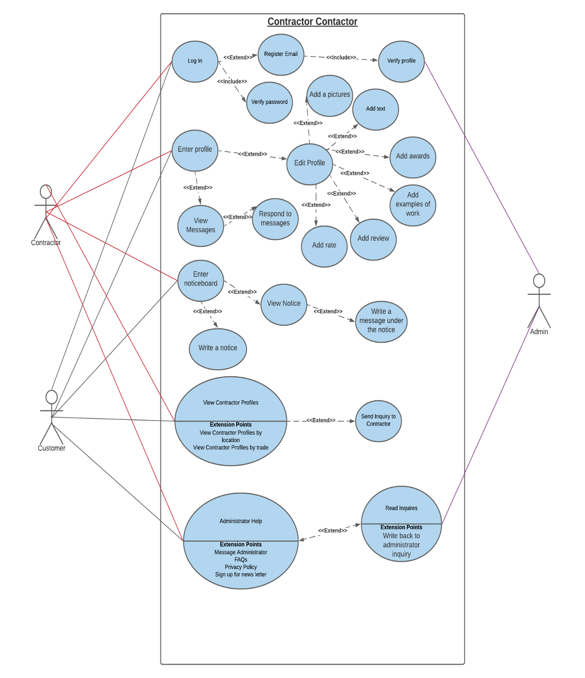

### Requirement 1 <Log In>

#### Description & Priority

Contractor will require a profile to use the site and put up contracts. They will need a user name and a password. The Contractor will have to be verified by the admin.

Customers do not need to sign in to use the site but will have the option to do so.

#### Use Case

**Scope and Description**

The scope of this use case is to show how the log in/register functionality works.

**Flow Description**

**Precondition**

The system is not in use.

**Activation**

This use case starts when a contractor or a customer logs in to the Web Application or if they have no account signs up and then logs in.

**Main flow**

1. The customer or the contractor enters the URL into their search engine.
2. Either user enters into the Web Application.
3. The customer or the contractor will enter a username and a password to log in.

**Alternate flow**

A1: Register a new Account

1. The customer or the contractor will enter an email address and a password to register.
2. The Administrator will accept the user if they deem the user fit.
3. The use case continues at position 1 of the main flow

**Exceptional flow**

E1: Incorrect User Sign In Details

1. The user enters the username and password
2. The system tells the user that the details are incorrect.
3. The system asks the user to re-enter the details

**Termination**

The system stops all activity when the user signs out.

**Post condition**

The system goes back into an idle condition.

### Requirement 2 < Enter Profile >

#### Description & Priority

This is when the user enters their profile on the Web Application. Here they will have the option to edit their account.

The contractor will have the ability to view the messages sent to him.

#### Use Case

**Scope and Description**

The scope of this use case is to show how the Profile works on the Web Application.

**Flow Description**

**Precondition**

The user is logged in.

**Activation**

This use case starts when the user clicks on “Enter Profile”.

**Main flow**

1. The user logs in.
2. The User clicks on “Enter Profile”

**Exceptional flow**

E1:

1. On Entering the Profile the contractor can edit their profile.
2. The contractor can edit the profile picture.
3. The contractor can edit the profile text.
4. The contractor can edit the profile awards.
5. The contractor can edit the profile examples of work.
6. The contractor can edit the profile reviews.
7. The contractor can edit the profile rate for work done.

E2:

1. The Contractor can view the inquiries from the customers.
2. The contractor can respond to these messages.

E3:

1. The Customer can edit their profile picture.
2. The Customer can edit their profile text.

**Termination**

The system stops all activity when the user signs out.

**Post condition**

The system goes back into an idle condition

### Requirement 3 < Enter Notice Board >

#### Description & Priority

This functionality allows the user of the Web Application to enter the Notice Board where they can see the contracts. Only the contractors can write responses on the Web Application.

#### Use Case

**Scope and Description**

The scope of this use case is to show how the Notice Board section works.

**Flow Description**

**Precondition**

The system is not in use.

**Activation**

This use case starts when a contractor or a customer clicks on the notice board section

**Main flow**

1. A user enters the web application
2. A user clicks on the notice board section.
3. They enter into this section.
4. The user clicks on a locality.
5. The user can scroll up and down and view the contracts availably in this area of Ireland.

**Exceptional flow**

E1:

1. A customer can write a notice
2. A Contractor can write a notice

E2:

1. A contractor will be able to write a message under the contract notice. You must be a registered contractor to write responses. This will generally be contact details or profile information.

**Termination**

The system stops all activity when the user signs out.

**Post condition**

The system goes back into an idle condition

### Requirement 4 < View Contractor Profile >

#### Description & Priority

This is the ability to see all the contractor profiles by location or trade or both.

#### Use Case

**Scope and Description**

The scope of this use case is to show how the “View Contractor Profiles Work”

**Flow Description**

**Precondition**

The system is not in use.

**Activation**

This use case starts when

**Main flow**

1. Enter the contractor profile section.
2. View Contractor by trade.
3. View Contractor by location.
4. View contractor by trade or location.
5. Click on the contractor profile.
6. Enter into the profile.

**Exceptional flow**

E1:

1. Enter your email.
2. Send the contractor a message

**Termination**

The system stops all activity when the user signs out.

**Post condition**

The system goes back into an idle condition

### Requirement 5 < Administrator Help >

#### Description & Priority

Here the user will have the ability to send the administrator a message. View the FAQs, see the privacy policy or sign up for the news latter

#### Use Case

**Scope and Description**

The scope of this use case is to show how the Administrator Help section works.

**Flow Description**

**Precondition**

The system is not in use.

**Activation**

This use case starts when a contractor or a customer clicks on the Administrator Help section

**Main flow**

1. The user enters the Administrator Help section.

**Exceptional flow**

E1:

1. The user can send the administrator a message, they must enter their email here.

E2:

1. The user can see the FAQs.

E3:

1. The use can see the privacy policy.

E4:

The user can enter their email to get a newsletter from the Administrator.

E5:

The Administrator can send an email back to the user.

**Termination**

The system stops all activity when the user signs out.

**Post condition**

The system goes back into an idle condition

## Non-Functional Requirements

The non-functional requirements are also required for the system to run effectively.

### Performance/Response time requirement

This will depend on the speed of the internet connection.

### Availability requirement

This shall be up and running for the 25th of April 2021.

### Recover requirement

The Web Application will have a backup system set up. This will back up the data files daily. This will keep the data safe and the website in good working order.

### Robustness requirement

The Web Application must be able to run despite errors and malfunctions in the code during the running of the program.

### Security requirement

All Contractors must create accounts and these profiles will be verified and made accountable by the administrator.

The customer can create an account too, this will be verified by the administrator too.

In both cases they must use the correct details to access the accounts.

Neither user’s info shall be available to anyone except the administrator.

### Reliability requirement

When the Web Application is available online it will run at full capacity for the user.

### Maintainability requirement

The code shall be clean, indented and very legible. This is for future updates and amendments.

### Portability requirement

This Web Application will be available on smartphone, laptop and PC.

### Extendibility requirement

Later down the road I may create another app exactly like this for the UK Market.

### Reusability requirement

This web application will be reusable for all different types of Contractors by trade and location. It will always be able to add new users and new data to the tables.

# GUI

Basic model

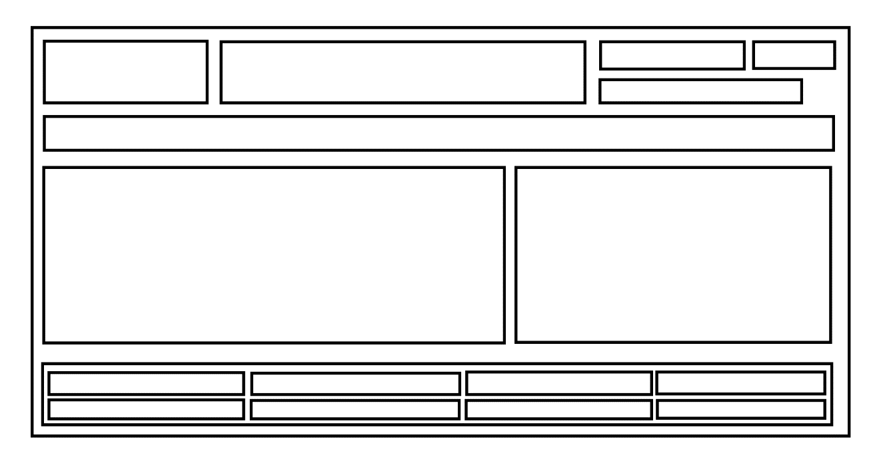

Main Page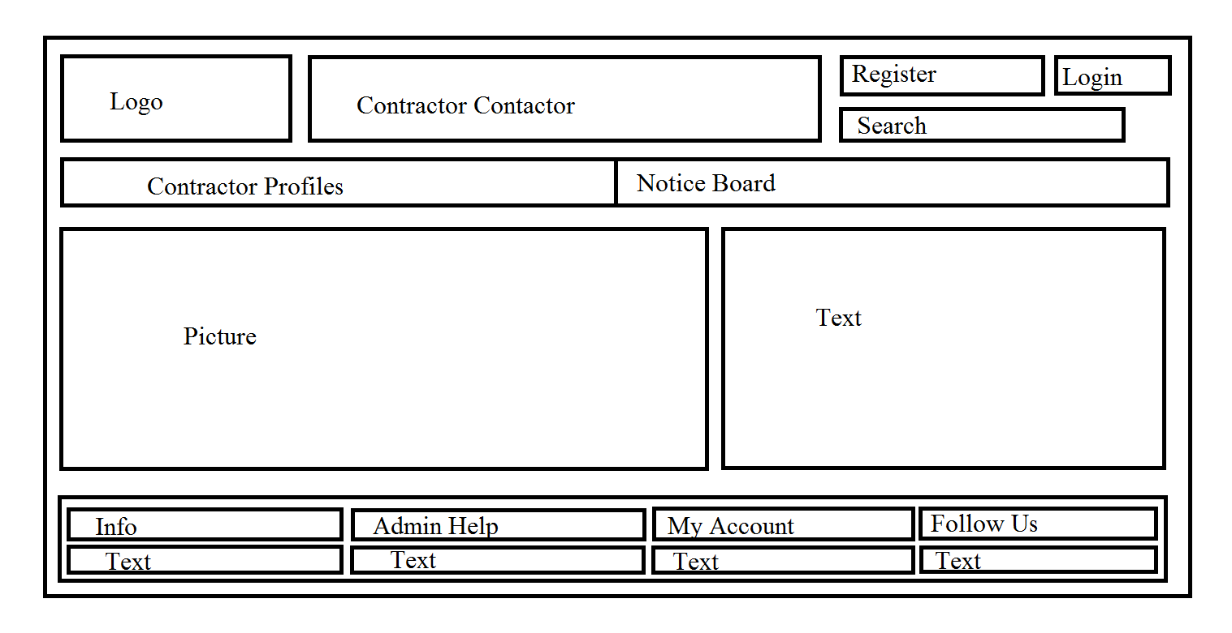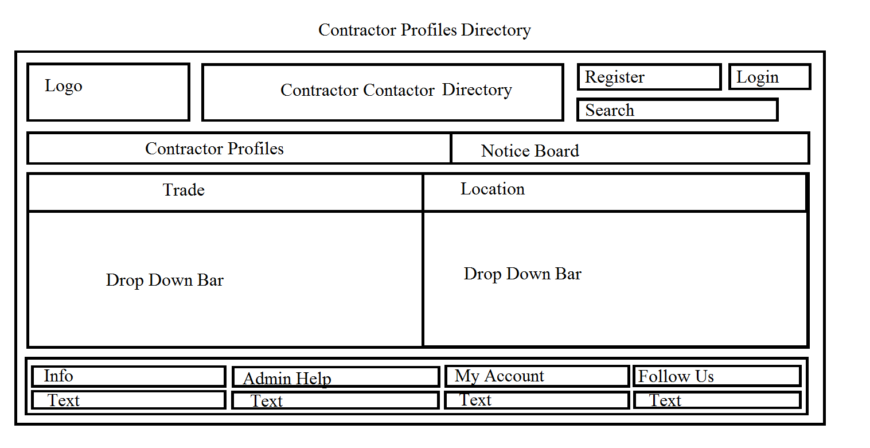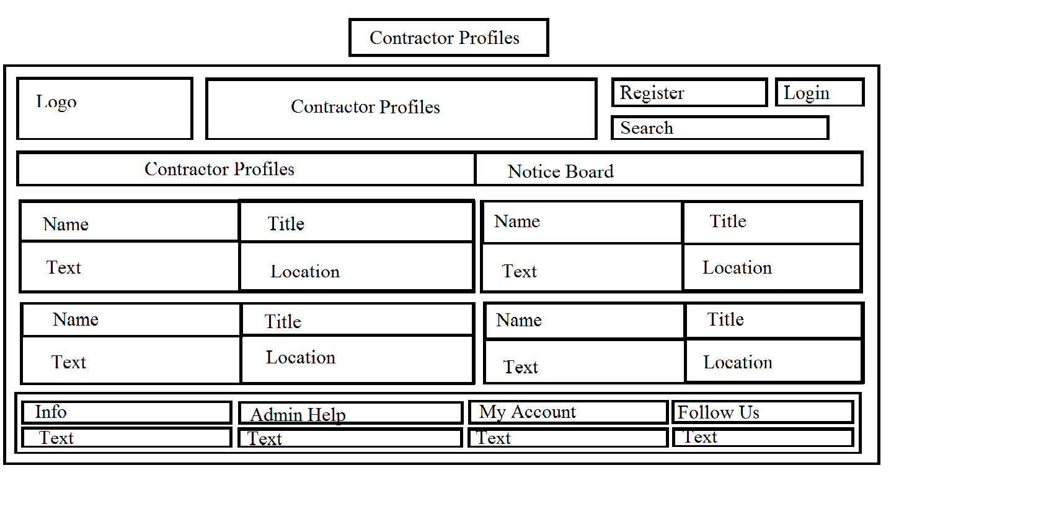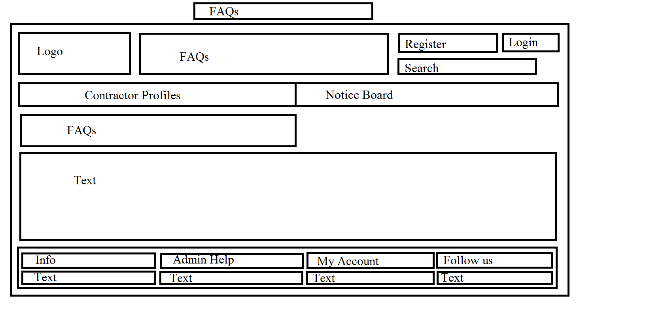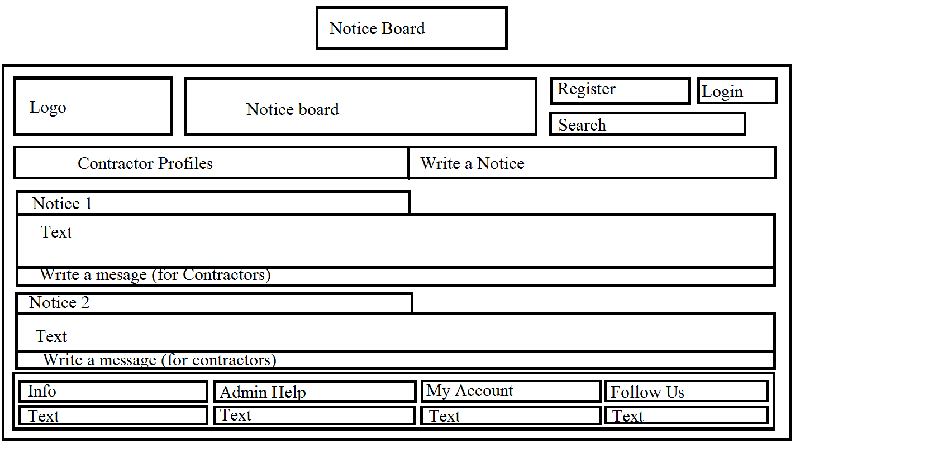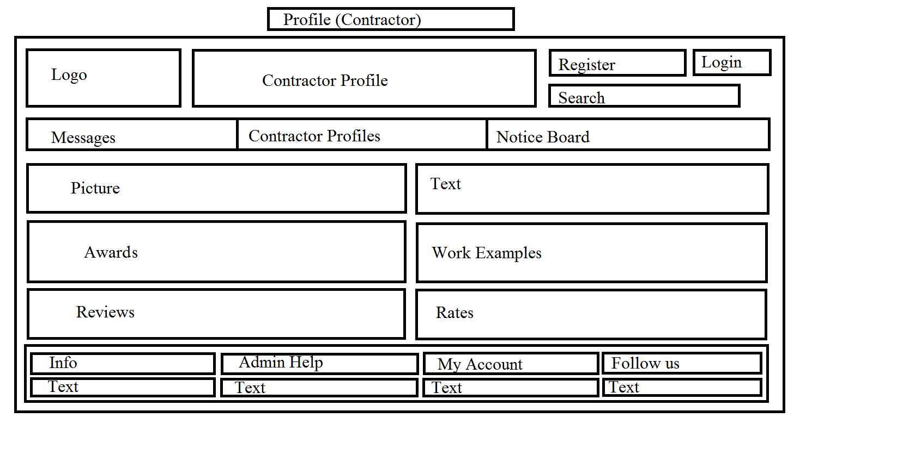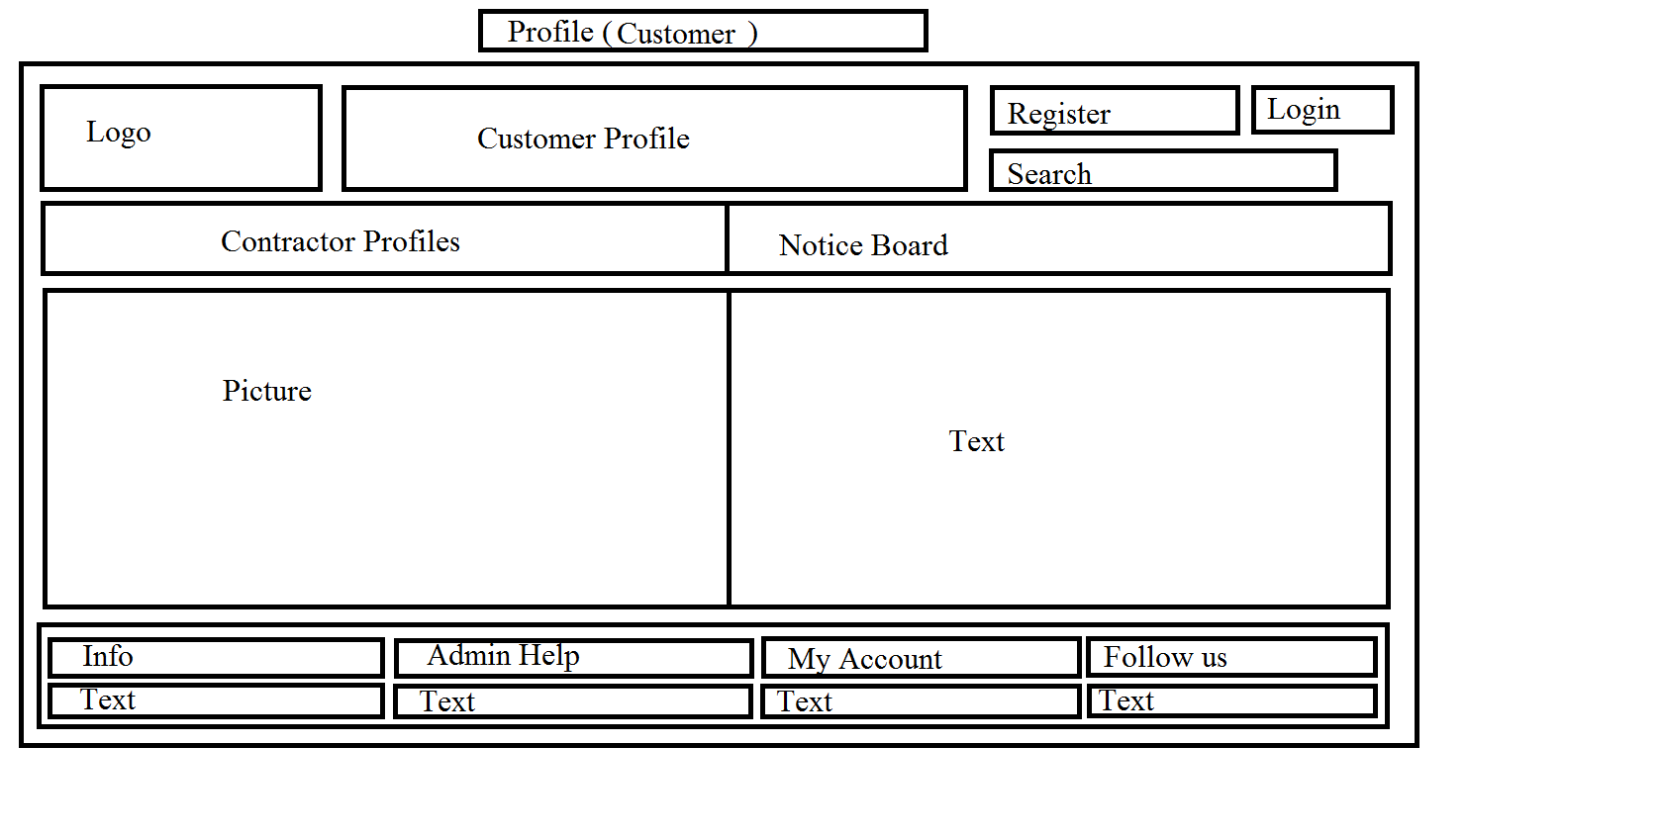

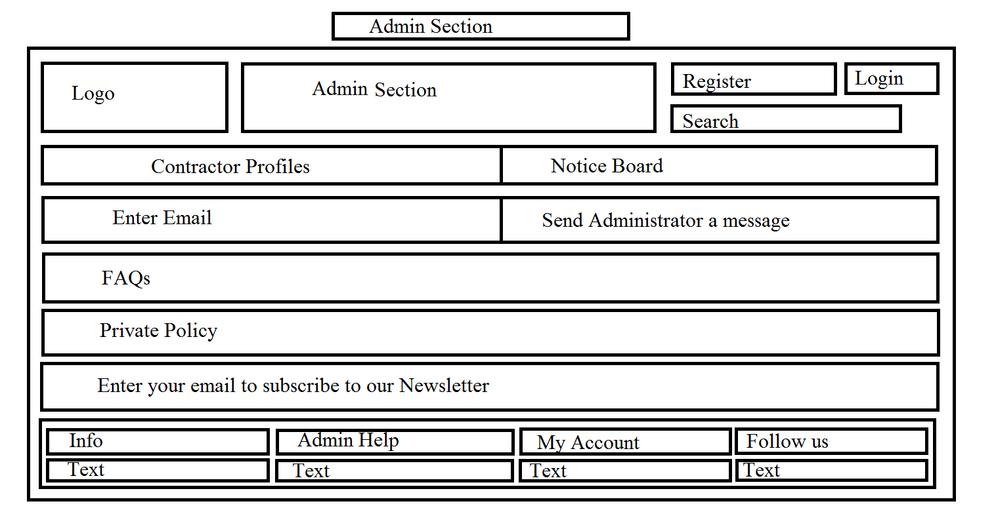

# System Architecture

# System Evolution

The initial Web application will be limited in its functionality. The main goal will be to get the functionalities above in good working order, with clean code that is easy to edit and update, and runnable so that the website can go live so that the Web Application can get users. Priority will be to make it easy to use and versatile to make it user friendly. It should also be aesthetically pleasing. The Web Application should be usable on a mobile, PC and tablet. Later versions will improve the messaging system, the security, the breakdown of the Contractor profiles to make the trades more segregated and to improve the maps and location aspect.